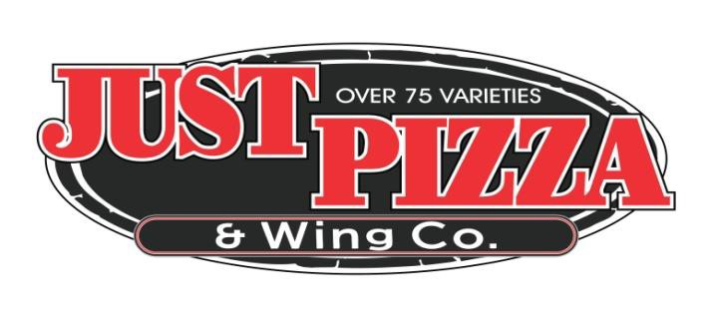

CATERING MENU
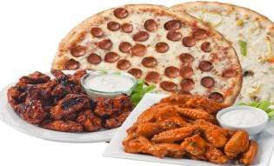$14.95 Per Person – 15 Person Minimum

ALL 4 ITEMS INCLUDED!

1. Choice of any of our Over 75 Varieties of Pizza
2. Choice of Wings – Any Flavor
3. Choice of Meats (1 choice)
BBQ Ribs, Roast Beef & Roll-Baked Chicken, Breaded Pork Chop
4. Choice of Sides (3 choices)
Mashed Potatoes w/Gravy, Baked Ziti, Fresh Cut Fries, Garlic Bread w/Mozz. Cheese, Steamed Vegetables, Pasta Salad, Potato Salad, Cole Slaw,
Chef Salad, Caesar Salad-Greek Salad

GREAT FOR

Office Parties · Holiday Parties ·

Family Gatherings · Tailgate Parties

Or Any Event

CALL OUR CATERING HOTLINE TODAY
800-251-5689

***7 DAYS PRIOR NOTICE REQUIRED

***PRICE SUBJECT TO CHANGE WITHOUT NOTICE

THANK YOU!

